Prism Awards 2013

Client: KFC / Yum South Africa (YUM! Restaurants International)
Campaign: Add Hope: Jouney of Hope
Categories: Corporate Responsibility

- OPENING STATEMENT

In 2012, KFC South Africa took an existing menu mechanic on the road in the form of solo-adventurer Riaan Manser’s bicycle journey of 4100km from Cape Town to Johannesburg - on half the calories that his body would need. This allowed the brand to evolve its three year Add Hope initiative from being an in-store mechanic aimed at overcoming “giving fatigue” into an integrated PR and social effort. One that stressed the plight of hungry children and at the same time, ingeniously met an unspoken consumer need to play a part in tackling an overwhelming social need.

Through securing R7-million in media coverage in two months, Ogilvy PR achieved a return on investment of 1:34. National, regional and community media amplification was delivered through 67 broadcast stories, 29 print features and articles and 24 online stories. Six earned five-minute mini documentaries were flighted twice weekly on national TV. 1 831 new online conversations were generated with over 4,3 million opportunities created to see the conversation. Critically, KFC will be able to fill 15-million tummies in 2013 due to the Journey of Hope.

- STATEMENT OF OPPORTUNITY AND/OR PROBLEM

  - Nature of Organisation / Initiative

The prevalence of hunger globally is nothing short of incomprehensible. In South Africa malnourishment impacts one fifth of children, a devastating 17.5% of youth under 17. That is 8.75-million potential doctors, teachers and scientists who go to bed at night with a hungry tummy. Since 2009, KFC’s response to this seemingly insurmountable problem has been simple, yet revolutionary in its pragmatism.

KFC has rallied a brand lead call-to-action initiative geared at educating South Africans about the impact of hunger, while driving consumers to “Add Hope” by playing their part in efforts to fill hungry tummies. Add Hope is an existing menu mechanic through which KFC has become a leader in purpose-driven marketing and communications. Its business objectives are to raise funds for hunger relief and specifically, to build on the funds raised every year by beating Year Ago funds raised.

  - Challenges to be Addressed

The Journey of Hope called for intensive campaign preparation, as well as content and schedule management. The South African context is dogged with “giving fatigue”, which often leads to cynicism or paralysis when it comes to consumers supporting yet another needy cause. For a brand to combat this social dynamic requires an ongoing demonstration of action. In addition, the Journey of Hope forged an opportunity for KFC to overcome a challenge that large brands face in that their reach is very often national. Regional and community engagement requires the brand to come up with a concept that has emotional meaning for all, despite diversity.

  - National, Regional and Community Focus

Through seeding of relevant content and conversations, the Journey of Hope reached South African audiences on a national, regional and community scale in a short period of time. Throughout the year, KFC campaigns tend to have national appeal. The journey broke through this dynamic by bringing Add Hope to communities in all nine provinces as Riaan Manser cycled visited Add Hope beneficiaries. As a result, Add Hope beneficiaries benefited significantly from campaign coverage.

- RESEARCH

The impact of Add Hope is tracked annually through funds raised and perceptions of consumers. This research informed campaign conceptualisation as well as the strategic direction behind communication support. The agency also assessed the reputational alignment between Riaan Manser and KFC, to ensure that his brand integrity was aligned with the motivation behind KFC and its Add Hope initiative. In addition, the KFC PR team consistently applies learnings from monthly perceptual and media profiling research delivered by Media Tenor.

- PLANNING

The public relations strategy was not focused solely on securing coverage. Rather, it was based on a three-tier “layered” content and storytelling strategy through which credible coverage was sought. Awareness generated became memorable by being emotive; relevant by being regional; and newsworthy by being national.

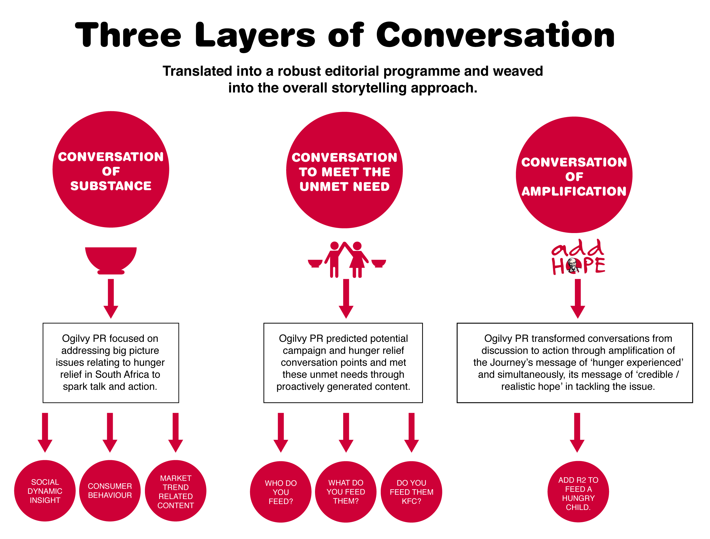

- EXECUTION

The campaign schedule was constructed to generate daily conversation momentum through:

- A weekly Journey of Hope mini documentary flighted on eTV (national viewership of 1,23-million). This five-minute segment was flighted every Wednesday evening at 6:30pm and was repeated on Saturdays at 2.00pm.
- Regular telephonic media interviews with major breakfast radio shows, focusing on high listenership regional radio stations every Monday morning.
- Media events and media press packs with collateral for seven national media stops. Journalists were encouraged to interview Riaan Manser 1:1 as he travelled through Cape Town, George, Port Elizabeth, Umtata, Bloemfontein, Pietermaritzburg and Durban.
- Thorough weekly media updates on Riaan Manser’s progress for print, online and broadcast media with links to the eTV episodes and a daily YouTube video diary.
- Consistent national and regional media lobbying together with providing journalists with updates, encouraging them to interview Riaan to report development and highlight Add Hope beneficiaries.
- A final event for Riaan Manser that included participation by celebrities, two national cricket team members and media in welcoming him to the last leg of his KFC Journey of Hope. This was held at Johannesburg’s renowned Park Station in conjunction with the 2011 Wall of Hope activation. Press packs and collateral were developed and post event lobbying and sell-ins were executed.

- EVALUATION

This PR lead campaign was exceptionally integrated. It saw traditional, digital and social media, work seamlessly with above-the-line and activations. It spurred South Africans into action through higher awareness of Add Hope on national and regional fronts. The pure guts of the Journey of Hope and Riaan Manser’s genuine efforts in taking on this arduous challenge on a limited calorie intake, to live as the hungry do, spoke volumes. One man and one brand proved that one R2 can make a difference in filling a hungry tummy; and if multiplied by many, that a hungry nation can be fed daily.

Campaign milestones included:

- Riaan Manser adopting KFC’s call to address the plight of hungry children in South Africa; embracing what it is like to be hungry and productive.
- Undertaking of an epic 4100km bicycle journey across South Africa spelling out the word “hope”, cycling 5 days a week over seven weeks.
- Riaan’s visits to significant KFC Add Hope beneficiaries and KFC stores while on the journey.

The Journey of Hope achieved a return on investment of 1:34 with media coverage of R7-million being secured in just two months. Specific communications achievements were:

- Flighting of six earned mini documentaries twice weekly on national TV.
- National, regional and community media amplification as the journey moved around South Africa through:
  - 29 print features and articles
  - 67 broadcast stories
  - 24 online stories
- Integrated social media engagement that allowed fans to increase Riaan’s calorie intake through Facebook and Twitter:
  - 1 831 new online conversations generated over 4,3million opportunities to see the conversation.
  - R1-million in online exposure was generated for the KFC brand.

The Journey of Hope took KFC from being a thought leader to a thought doer. It allowed KFC to use the power of storytelling to connect those living with hunger with consumers who are often removed from this reality. More importantly, the campaign has, and will continue to enable the brand to tell more stories that magnify hope - authentic stories that Add Hope.

Annexures
Journey of Hope eTV Diary of Hope
Examples
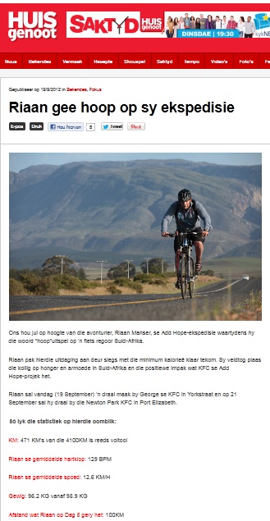
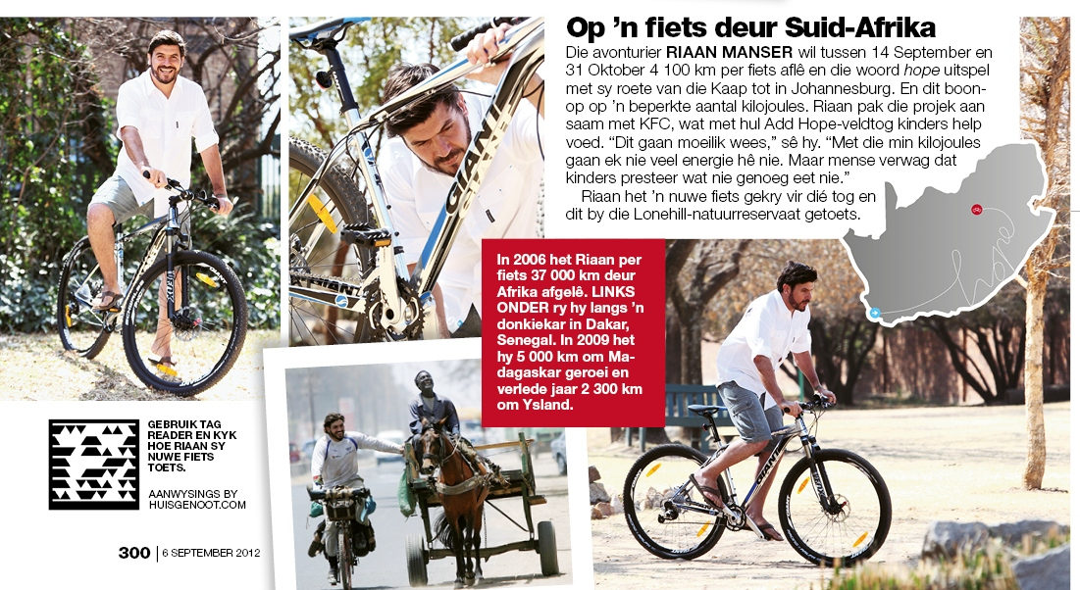
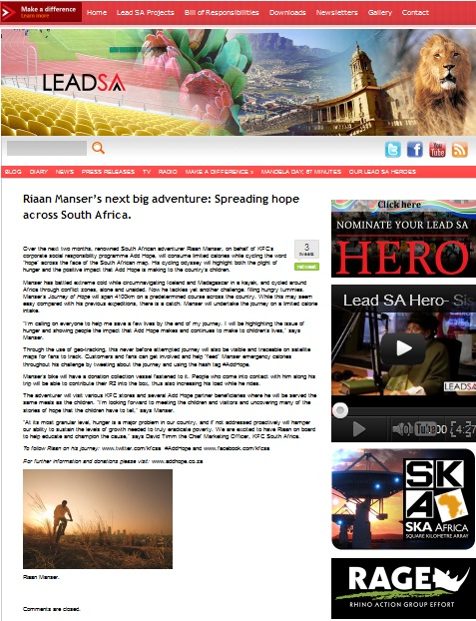
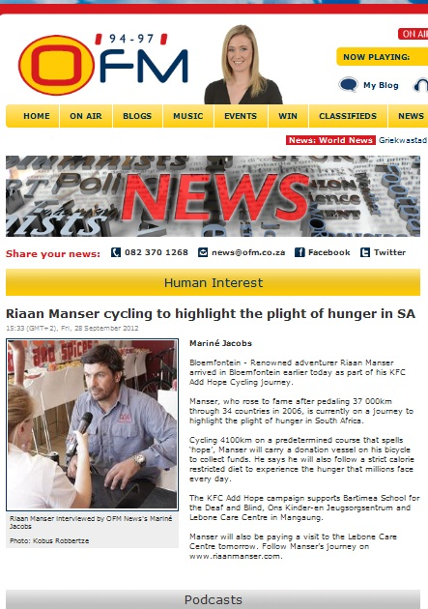

General Household Survey 2002 - 2010. Pretoria: Stats SA, December 2011

