PRISA PRISM AWARDS

ENTRY SUMMARY

Category: TECHNOLOGY
Consultancy: Atmosphere Communications
Client: MIX TELEMATICS - WAZE
Project: LAUNCH OF WAZE APP IN SOUTH AFRICA
CONTACT: MARISE LERM - 021 461 2117
MARISE@ATMOSPHERE.CO.ZA

OVERVIEW

“Our campaign had a clear goal: increase the brand awareness of Waze in South Africa and also accelerate the number of app downloads and users. The Atmosphere team got their teeth stuck into the challenge. Their out-of-the-box thinking and proactive, hands-on approach combined with their outstanding media relationships resulted in a cross-media campaign that gave Waze a successful kick-start in SA. Thanks to Atmosphere, the Waze user base shot up from 30 000 to 68 500 between February and May 2012 and even more importantly, the total number of driven kilometres recorded by the app increased from roughly 3.5 million in February to over 7 million in May.”
Sabine Klisch, Marketing Manager (International), MiX Telematics

The free traffic and navigation app, Waze, launched globally in 2009 and despite local early adopters, there was low brand awareness in South Africa when JSE-listed MiX Telematics, leader in vehicle tracking and fleet management solutions partnered with Waze. Atmosphere had been given a strong business goal: double the user signups within three months.
While the campaign delivered 57 pieces of on-message publicity to the value of R1.4 million (AVE 1:1), the most significant success indicator was a 228% increase in Waze users from 30 000 to 68 500. Although stimulating user engagement was not set as a business objective, our campaign resulted in a 251% increase in number of kilometers driven.
These remarkable business results were delivered in the absence of any other marketing activities, highlighting the tangible difference a measurable PR campaign can make.

CHALLENGES AND OPPORTUNITIES

Challenges
- Success depends on user-sharing
Crowd-sourcing and idle-sourcing through always-on GPS as well as location services on accelerometer-enabled smartphones mean that users broadcast data about their location and activities. Waze relies on this technology to build maps and give real time updates – the more users use it, the more accurate the map data. The challenge was to stimulate user uptake, but also ensure that users don’t discard the app due to its incompleteness - user engagement had to be encouraged. It was imperative to clearly communicate that Waze is a community driven app and that its success depends on user-sharing - both passively and actively.

- Domain of the techies
Early adopters and techies understood and used the app, but we needed to illustrate real tangible benefits to a much wider audience. Tailored messages where created for tech, business, motoring and lifestyle media. So even the mum on school run received a simplified message she could relate to.

- Cost of broadband
Compared to global standards, SA’s broadband costs are exorbitant and using the app impacts on users’ monthly broadband costs.

- Safety and battery life
Driving while using a mobile in SA is illegal, however we required active drivers in real-time traffic to upload information to ensure map accuracy. Research showed that even in idle-mode the app ate battery life. These insights were incorporated into our approach and we adapted our communication messages accordingly.

Opportunities
- It’s free, quick and easy
Traffic is dynamic, yet GPS devices fail to reflect this, leaving drivers in the dark. A free user-friendly app had tangible benefits. In addition, when users drive with Waze open, they passively contribute real-time road information that gives other Wazers an up-to-the-minute traffic snapshot.

- A ‘captive audience’
With Waze the key benefit is the community-contributed element of the app – and one can’t get a better captive contributor than a frustrated commuter stuck in traffic. The app was ‘on trend’ – making users’ part of your product solution.

OUR RESEARCH

Competitor research
A competitor analysis indicated that South Africans were loyal to Garmin and TomTom and perceived these products as reliable global leaders. Blogs and websites trawled by the team also revealed potential consumer complaints.

Trend reports:
Extensive online research identified several trends including crowd and idle-sourcing, gamification and the growth of the “presumers and custowners”, which all highlighted that Waze, as a community-enabled app, was spot on.

Product testing:
Atmosphere used the app and provided comprehensive feedback. This influenced the campaign mechanics and determined the following:
1) The more users, the better the product. This influenced our decision to launch in Jhb during peak hour traffic.
2) Broadband costs associated with the app was unexpected and was addressed by focusing on the fact that Waze is a free download and most GPS devices are expensive with paid-for maps.

Blogs and media outlet research:
Print, online and broadcast media were researched for 1) relevance; 2) target audience and 3) reach. We focussed on one-on-ones with business, IT, motoring, travel and lifestyle media. Media were grouped in regional areas and main focus was placed on those based in Johannesburg and Cape Town.

Understanding Waze offering:
In-depth meetings with our client’s IT and product team assisted us to unpack potential challenges which directed our PR approach and helped tailor messaging.

KEY INSIGHTS

Crowd-based problem solving was fuelling endless innovations in 2012 and Waze was earmarked as a game-changer in the navigation and GPS sector. A survey showed drivers experienced high stress levels, feel powerless and frustrated. Waze tapped into this by positioning the app as a tool which empowers commuters to take control. Communication is most effective when potential users are at their most receptive –during rush hour– thus the decision to use radio as a channel.

PLANNING OF STRATEGY

Business objectives
- Grow user numbers from 30 000 to 75 000 from February 2012 – May 2012

Communications objectives
- Position Waze as a free traffic app for smartphones that allows users to outsmart and beat the traffic;
- Expose as many commuters as possible to Waze and encourage them to download and use the app;
- Manage potential reputational issues by communicating that the success of the app is directly linked to the number of active users; that it only works with a hands-free kit; and although the app is free, there are associated broadband costs

Key messages
- Waze is a free traffic app for smartphones that allows users to outsmart and beat the traffic together – it is a community-driven social app, updated by drivers for drivers;
- Waze saves time by alerting and routing users around slow-moving traffic or obstacles, resulting in less spend on fuel and less traffic-related stress;
- Map and traffic information is automatically collected and generated as users drive with the Waze app open;
- Users can also actively report and update other Waze community members with what’s happening on the road;
- Waze must always be used in conjunction with a hands free car kit;
- Waze is brought to SA by MiX Telematics, a global leader in vehicle tracking and fleet management solutions.

Target audiences
- Primary: South Africans with smartphones who commute daily using their own vehicles.
- Secondary: South Africans with smartphones who commute with friends or family.

Media channels
- Targeted media including print, broadcast and online
EXECUTION OF THE STRATEGY

Tactic 1: Traditional media relations
Instead of an expensive launch event, we met with target media on a one-on-one basis to demo Waze. This fast-tracked the product review process – the media saw how the app worked and could ask questions while experiencing it. Media releases were tailored to media beat and publications which resulted in 100% positive coverage from road show media.

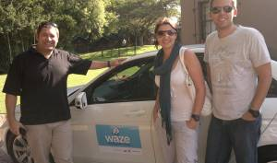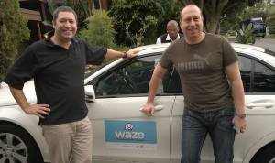
Tactic 2: Roadside activation
A week later, 5 500 Waze-branded jam doughnuts with the simple message: “Stuck in a jam,” were handed to commuters at four intersections in Johannesburg. Packaging carried information and instructions about Waze.
The activation coincided with pre-promos for the Waze competition aired on 5FM. During the two-day activation period, sign-ups spiked by 229%.
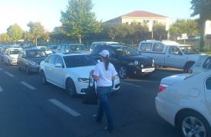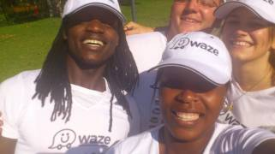

Tactic 3: Radio competition
Following the activation, we ran a week-long competition on 5FM during drive-time so as to spread awareness and create talkability.
Listeners called to share their weirdest experience in traffic and the best anecdote won a small daily cash prize. This was supported by a live-read and a call-to-action to download the app.

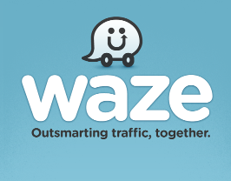

EVALUATION

Business criteria for campaign success | Delivered by Atmosphere
- Double user numbers from 30 000 to 75 000 from February to May 2012. | - User numbers increased from 30 000 to 68 500, reflecting 228% increase for the period.  - 251% increase in number of kilometers driven during campaign, underscores high level of user engagement. *See Graph 1, p7 and Graph 3, p8.
- Expose as many commuters as possible to Waze and encourage download and use over a short time period. | - Signups spiked with 880% during the latter part of our campaign. *See Graph 1, p8.  - Signups spiked with 229% during activation period.  - 5 500 commuters reached at intersections in Jhb.  - Anticipated reach of 8 million impressions via radio, TV, print and online media.
- Position Waze as free traffic app that allows users to outsmart and beat the traffic together. | - Atmosphere secured 57 items of media coverage (90% over target of 30, all positive), valued at just under R1.4 million (AVE: 1:1).
- Leverage media relationships to demo Waze with key journalists and influencers on one-on-one basis. | - 16 x interviews with top tier media and tailored media releases with lifestyle, technical, motoring and business angles developed for each –100% attendance secured.  - All targeted media ran Waze media release with 98% key message penetration  - Media exposure across wide range of channels with balanced split amongst print, online, and broadcast media. *See Graph 2 on page 7.
- Manage potential reputational issues by managing message carefully and immediately addressing any incorrect or negative reporting. | - 100% positive media coverage with no mention of potential negative issues.  - All targeted media ran Waze media release with 98% key message penetration

Graph 1: PR activities linked to user acquisition figures

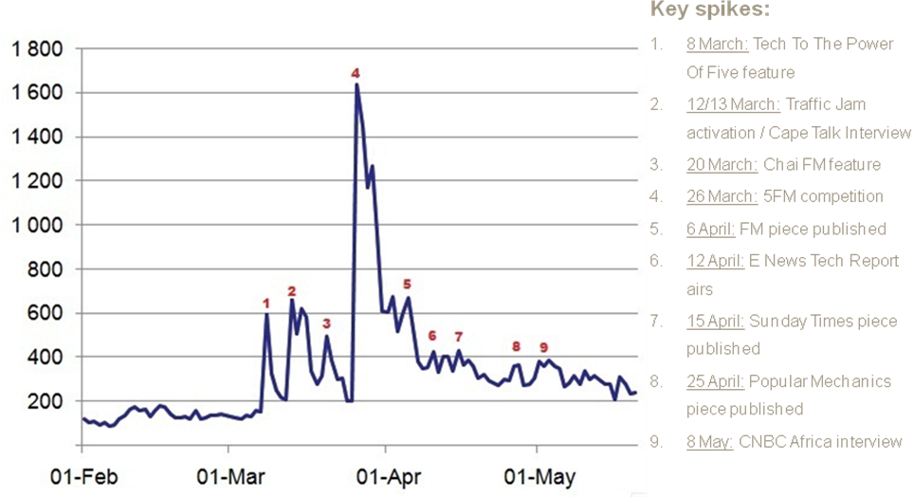

Graph 2: Media exposure across channels:

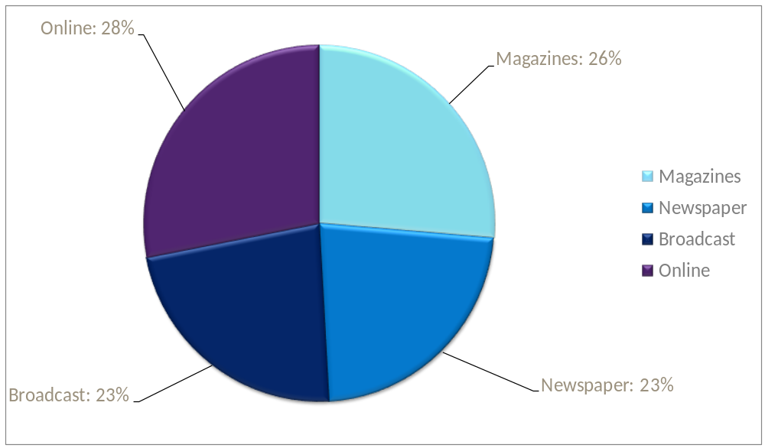

Graph 3: Number of kilometres driven during campaign period:

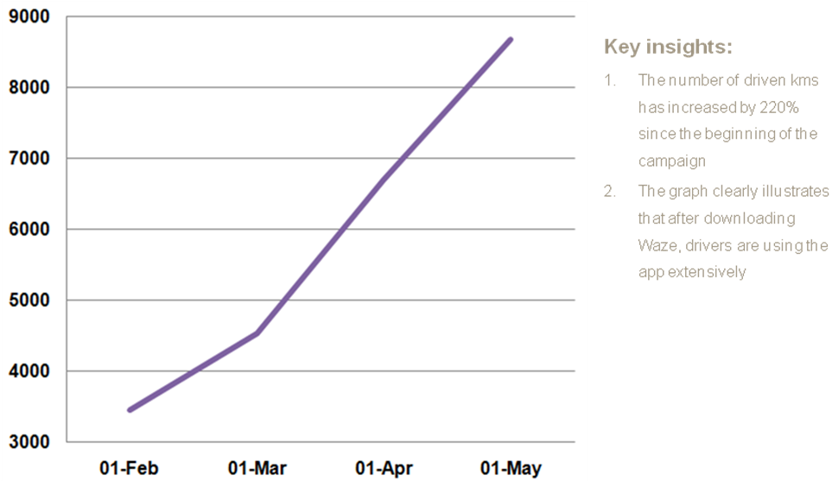

CONCLUSION

Atmosphere used a variety of PR tools to delivered breakthrough results and met the overall business objective within a 10% margin of the user acquisition targets.

While it is not always possible to measure the true impact of PR activities without extensive research, the weekly acquisition data supplied by the client made it possible to directly measure the value of our activities, which is clearly illustrated in Graph 1 above. The spikes indicate notable increases in user numbers which are directly linked to positive media coverage and mentions, the two-day activations and the week-long radio competition.

Another key indicator of the success of the campaign is the 251% increase in kilometres driven during the campaign period, which not only shows that users uploaded the app, but that they kept on using it after installing it – a true measure of the success of the campaign.
COVERAGE

Date | Media outlet | Headline/subject of interview | A.V.E (1:1)
01-Mar-12 | WhatNow | Emerging Developments in Enterprise Information Management | R 15 081.55
05-Mar-12 | nafisa.co.za | Waze: Free live traffic App | R 12 000.00
07-Mar-12 | ZA Tech Show | Waze discussion | R 12 000.00
08-Mar-12 | 5fm Radio | Tech to the power of 5 | R 33 976.00
12-Mar-12 | Memeburn.com | Crowdsourced traffic app Waze to launch in S.A. | R 7 821.27
13-Mar-12 | Cape Talk: Hard Drive | Waze Launch | R 23 045.63
13-Mar-12 | goTravel24.com | App to help beat traffic jams | R 21 172.18
14-Mar-12 | The Citizen, Citi Motoring | New Waze to monitor all those traffic woes | R 24 906.06
14-Mar-12 | marcforrest.com | Waze takes off in SA | R 18 127.59
15-Mar-12 | FinWeek (Eng) | The best Waze to go | R 73 404.43
15-Mar-12 | FinWeek (Afr) | Val in die pad met Waze | R 73 404.43
15-Mar-12 | Business Day: Motor News | Finding new Waze to navigate | R 20 801.65
15-Mar-12 | Pretoria News | App offers plenty of other Waze | R 13 974.29
15-Mar-12 | The Star: Motoring News | App offers plenty of other Waze | R 31 430.67
15-Mar-12 | Die Burger | Waze | R 24 141.27
15-Mar-12 | Cape Times | App offers plenty of other Waze | R 9 319.09
15-Mar-12 | Daily News: Motoring news | App offers plenty of other Waze | R 7 489.72
16-Mar-12 | Mail & Guardian Online | Social network paves the Waze | R 32 618.88
16-Mar-12 | Mail & Guardian | Social network paves the Waze | R 39 321.28
16-Mar-12 | Mercury Motoring | App offers plenty of other Waze | R 7 584.93
16-Mar-12 | TechCentral.co.za | Social network paves the Waze | R 11 155.91
16-Mar-12 | businessday.co.za | Finding new ‘Waze’ to navigate | R 24 575.88
19-Mar-12 | iAfrica.co.za | Crowdsource' maps taking off | R 43 214.31
20-Mar-12 | Chai FM breakfast | Tech Update | R 32 800.00
20-Mar-12 | Cape Talk : Business News | Waze Application | R 2 707.37
20-Mar-12 | Themarketingsite.com | Free crowd-sourced traffic app “Waze” launches in SA | R 20 395.38
20-Mar-12 | Ioltechnology.co.za | Users create Wikipedia-style maps of world | R 14 771.68
29-Mar-12 | Southern Cape Motoring Guide | New Waze to monitor traffic woes | R 6 047.13
31-Mar-12 | My Broadband Online | Social network paves the Waze | R 19 856.88
01-Apr-12 | FHM | Waze App | R 24 096.70
01-Apr-12 | The Ballito | Waze navigation application | R 2 509.15
01-Apr-12 | Airport Magazine | Outsmarting Traffic Together | R 2 440.91
05-Apr-12 | Financial Mail Online | Waze About Town | R 9 723.60
06-Apr-12 | Financial Mail | Waze About Town | R 23 728.07
05-Apr-12 | gearburn.com | Waze: the app that saves you from traffic and fines [Review] | R 14 138.28
11-Apr-12 | iMod.co.za | Everyday Awesomeness: a free traffic and navigation app | R 12 000.00
12-Apr-12 | E News Channel - Tech Report | Waze navigation application | R 92 000.00
13-Apr-12 | E News Channel - Tech Report | Waze navigation application | R 42 166.67
14-Apr-12 | E News Channel - Tech Report | Waze navigation application | R 61 066.67
14-Apr-12 | E News Channel - Tech Report | Waze navigation application | R 84 700.00
15-Apr-12 | Sunday Times Lifestyle Magazine | Geek Chic | R 16 447.16
15-Apr-12 | TimesLive.co.za | Geek Chic | R 16 260.90
17-Apr-12 | E News Channel - Tech Report | Waze navigation application | R 61 066.67
19-Apr-12 | Heat Magazine | The Heat Hot List | R 11 153.66
01-May-12 | Top Car | Waze Platform | R 3 073.85
01-May-12 | TechSmart | Waze: Drive Safe | R 9 500.00
01-May-12 | Leisure Wheels | Making your Waze through Traffic | R 13 676.06
01-May-12 | Indwe | Waze SA | R 2 736.00
01-May-12 | Popular Mechanics | Want to outsmart traffic? Then get Waze | R 67 129.12
01-May-12 | Car Magazine | WAZE | R 13 855.01
01-May-12 | Voila Magazine | Get some direction | R 2 703.28
08-May-12 | CNBC Africa | Waze SA (Interview) | R 49 333.33
12-May-12 | CNBC Africa | Waze SA (Interview) - repeat | R 17 208.33
13-May-12 | CNBC Africa | Waze SA (Interview) - repeat | R 17 208.33
03-May-12 | You | New on the move | R 9 892.67
03-May-12 | Huisgenoot | Nuut App vir GPS | R 15 151.38
14-May-12 | Practical Marketing Online | Waze user base sees phenomenal growth in South Africa | R 12 000.00
17-May-12 | Daily News | Growing number of Waze to beat the traffic blues | R 3 490.97
18-May-12 | Mercury Motoring | Growing number of Waze to beat the traffic blues | R 3 522.71
TOTAL: |  |  | R 1 391 124.94

